- If the name of mdk is changed, you need to include the new mdk on CCS Edit. Just like follow:
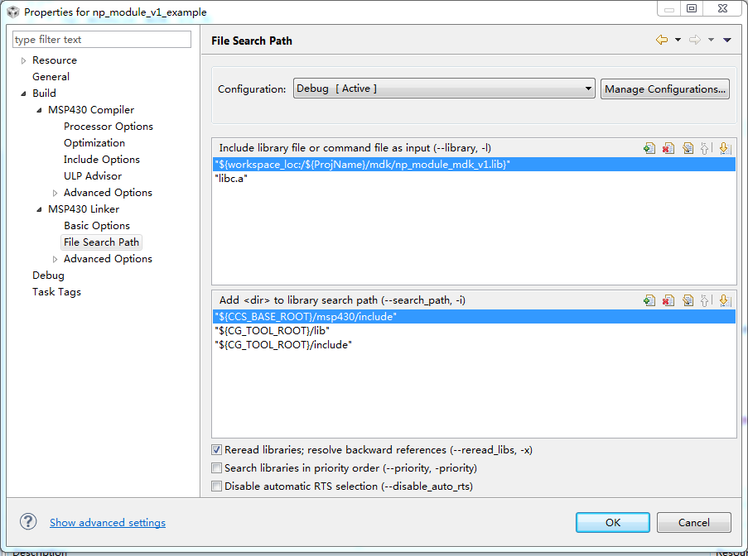

- The “np_module_mdk_v1.0.1.h” which is included on the code of developer also need to rename.
